Bio data

<html>

<head>

<title>Monika Sri</title>

</head>

<body bgcolor="LIGHTPINK">

<font color="PURPLE" face="Gigi" size="6">

<center><marquee><b>Monika Sri S Bio-Data</b></marquee></center>

<br>

<hr color="purple" width="50">

<br>

<center>

<img src="C:\Users\3BSCCSA63\Downloads\download.jpg" width="100" height="100" border="2">

</center>

</font>

<font color="purple" face="Gigi" size="5">

<br><br>

<b>Name:</b> Monika Sri S S <br>

<b>DOB:</b> 01-07-2006 <br>

<b>Father Name:</b> Sri Dharmaraj S <br>

<b>Mother Name:</b> Vijaya Rani S <br>

<b>Gender:</b> Female <br>

<b>Address:</b> Theni, Tamil Nadu <br>

<b>Phone Number:</b> +91-1234567890 <br>

<b>Email:</b> 23bcs063@psgrkcw.ac.in <br>

<b>Education:</b> B.Sc. Computer Science <br>

<a href="Z:\hobbbies.html">my hobbies</a>

</font>

</body>

</html>

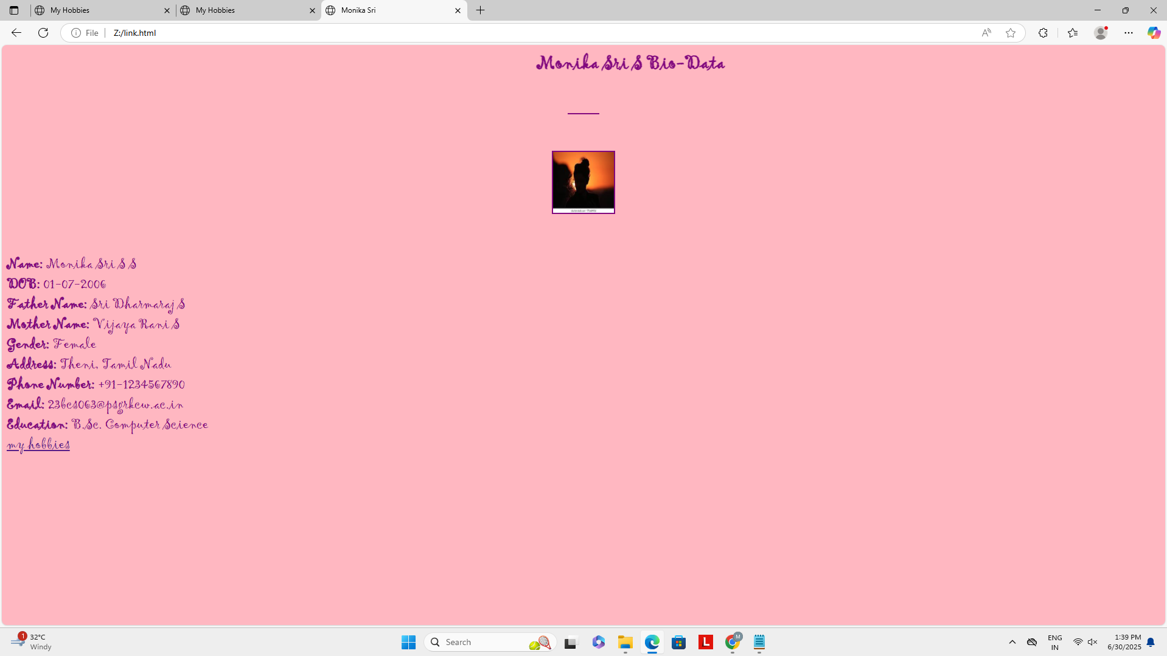 hobbies

<html lang="en">

<head>

<meta charset="UTF-8">

<title>My Hobbies</title>

</head>

<body>

<h2>My Hobbies</h2>

<ul>

<li>learning new things</li>

<li>experiseing new things</li>

<li>Sketching</li>

<li>reviewing</li>

</ul>

<a href="Z:\link.html">Back to Bio-Data</a>

</body>

</html>

